Heritage: Where Have The Old Pubs Gone?
Youngsters these days are a fickle lot, or so it seems, as every time a new pub, disco or restaurant opens, they flock to it in large numbers, proclaiming it, “The best so far”. Then within a few weeks, another establishment will open with some new gimmick and the ‘in-crowd’ will shift their allegiance and the former hotspot will simply fade away.
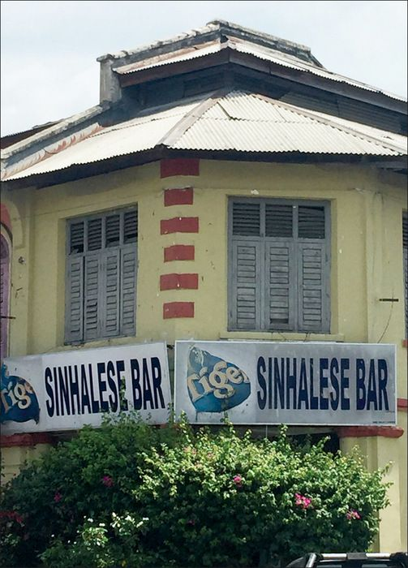
Consequently, the face of Ipoh is continually changing; having said that, there are a few coffee shops and hawker stalls that seem to last forever. Why? Because their fare is outstandingly good; prepared to traditional heritage recipes, they are inexpensive and favoured by young and old alike. It is these that the weekend and school holiday visitors, from all over the Peninsula, come to enjoy.
But what about the Chinese and non-Islamic Indians that enjoy alcohol? What is there for them? And are any of them longstanding and famous nationwide? Unfortunately, the answer is no! Ipoh no longer has a range of pubs and clubs that we can really call heritage. The FMS Bar has been given a total makeover and can no longer be considered as a heritage pub. All the others have gone, leaving us with only one choice, the Sinhalese Bar in Old Town. This is a rather drab place, opened in 1931, where nothing seems to have changed much since it was founded by the current owners’ father. Don’t be put off by this description for, despite its rather basic outfitting, it is a popular place with its own, regular clientele. Generally, you will not find it overcrowded with enthusiastic imbibers. Nonetheless, if you want to get the pre-war atmosphere and the feeling of how Ipoh used to be, then this is the place to visit – and the beer is cold, just what you need on a hot day!
The Scotch Pub in Ipoh Garden South is a different kettle of fish. It has been with us for some years but cannot really be considered as a heritage. Having said that, it remains a popular venue for both drinks and food.
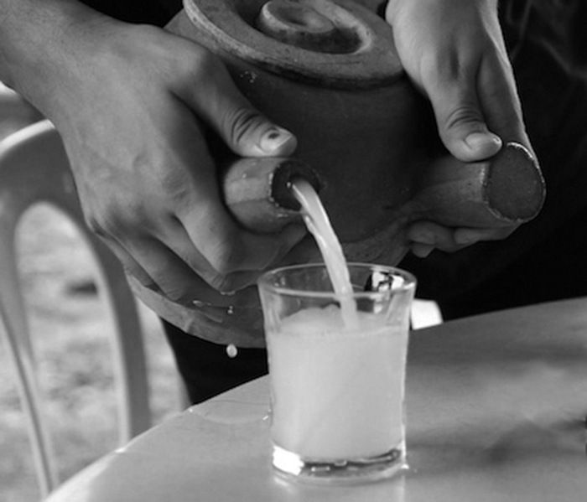
As you will see, Ipoh is rather short on traditional old pubs. Sure there are many new pubs out there, mostly seeming to be designed to attract the younger set, blasting out modern music, if you can call it that, and claiming high prices for a range of imported beers and exotic cocktails. I think I shall stick with the Sinhalese Bar!
Of course, I could visit one of our toddy shops for a cool jug of that traditional Indian alcohol made from collecting the sap of coconut flowers. Popular across the south Indian states of Tamil Nadu and Kerala, that is real Ipoh heritage brought here under British rule. The effect might be the same in the end, but I doubt it would be as enjoyable as a bottle of local beer.

